# **Assignment 1**

## **Solution**

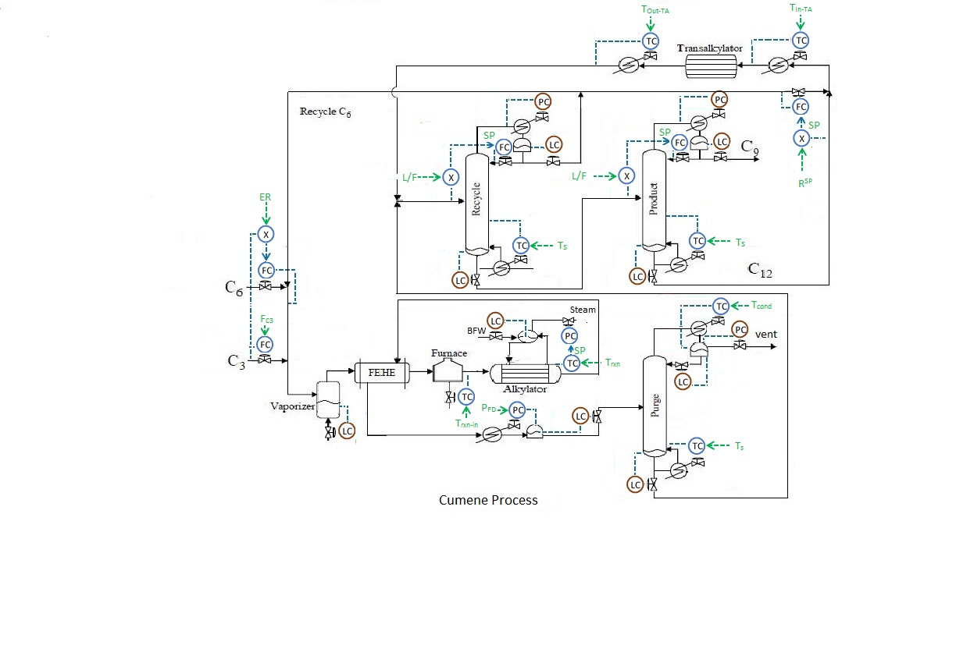**Flowsheet 1**

[FC3], [ER], [TRXN-,IN],[TRXN], [PFD], [TCND]COL1 , [TS]COL1 , [L/F]COL2 , [TS]COL2 , [L/F]COL3 , [TS]COL3 , [RSP], [TIN-TA], [T OUT-TA]

Control Degree of Freedom=26

LC= 09

Column P= 03

SS DOF= 14

**Flowsheet 2**

[FTOT], [TLLX­-IN], [E/F], [L/F], [ XPROD]

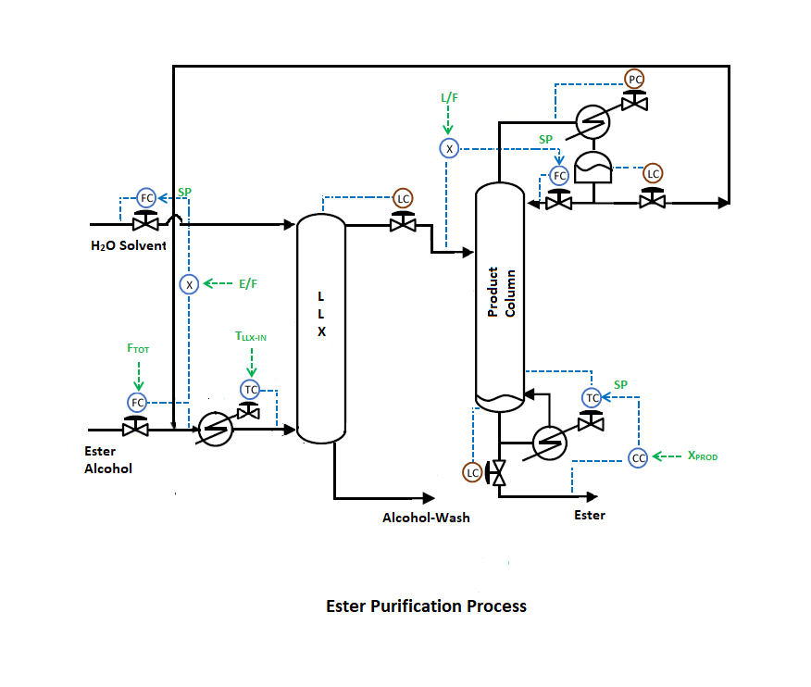

Control Degree of Freedom=09

LC= 03

Column P= 01

SS DOF= 05

**Flowsheet 3**

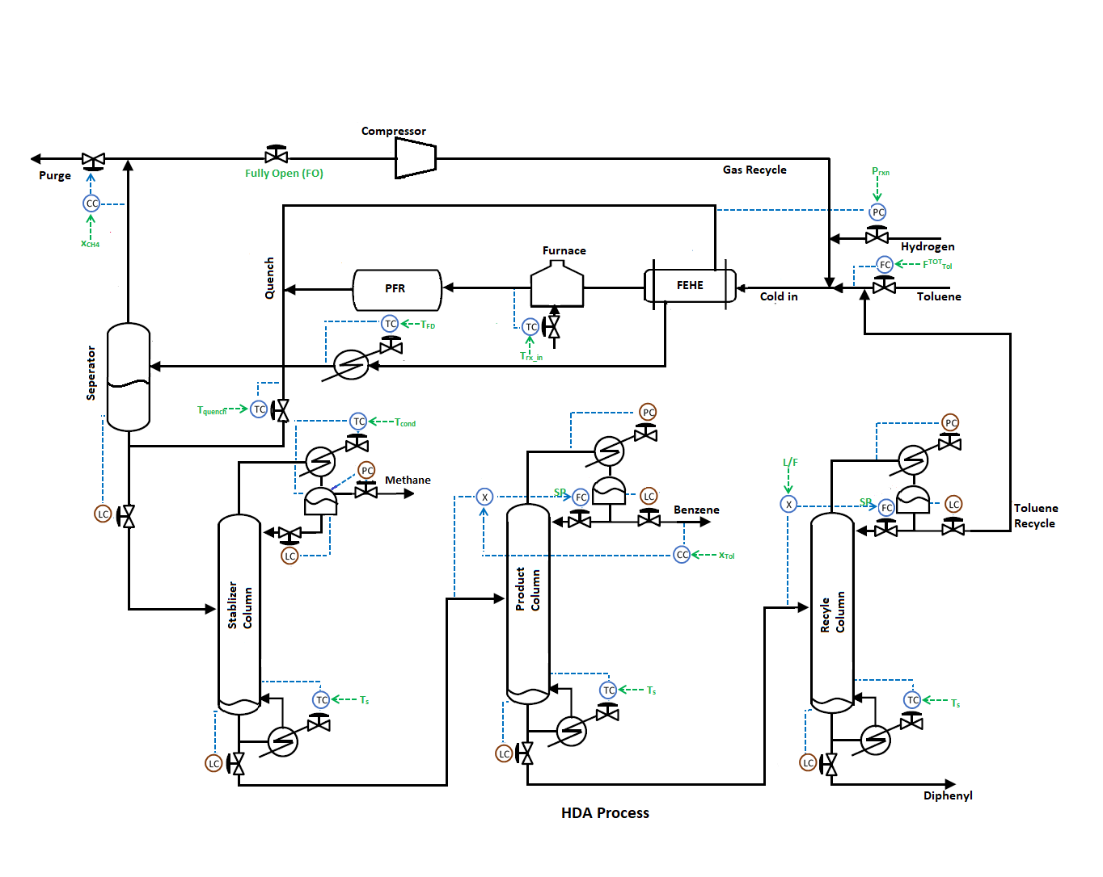

[FTOTTol], [Prxn], [Trx_in], [TFD], [xCH4], [Valvecomp = FO]

[Tquench], [Tcond]1, [Ts]1, [xDc7]2, [Ts]2, [L/F]3, [Ts]3

Control Degree of freedom = 23

LC = 07

Column PC = 03

SS DOF = 13

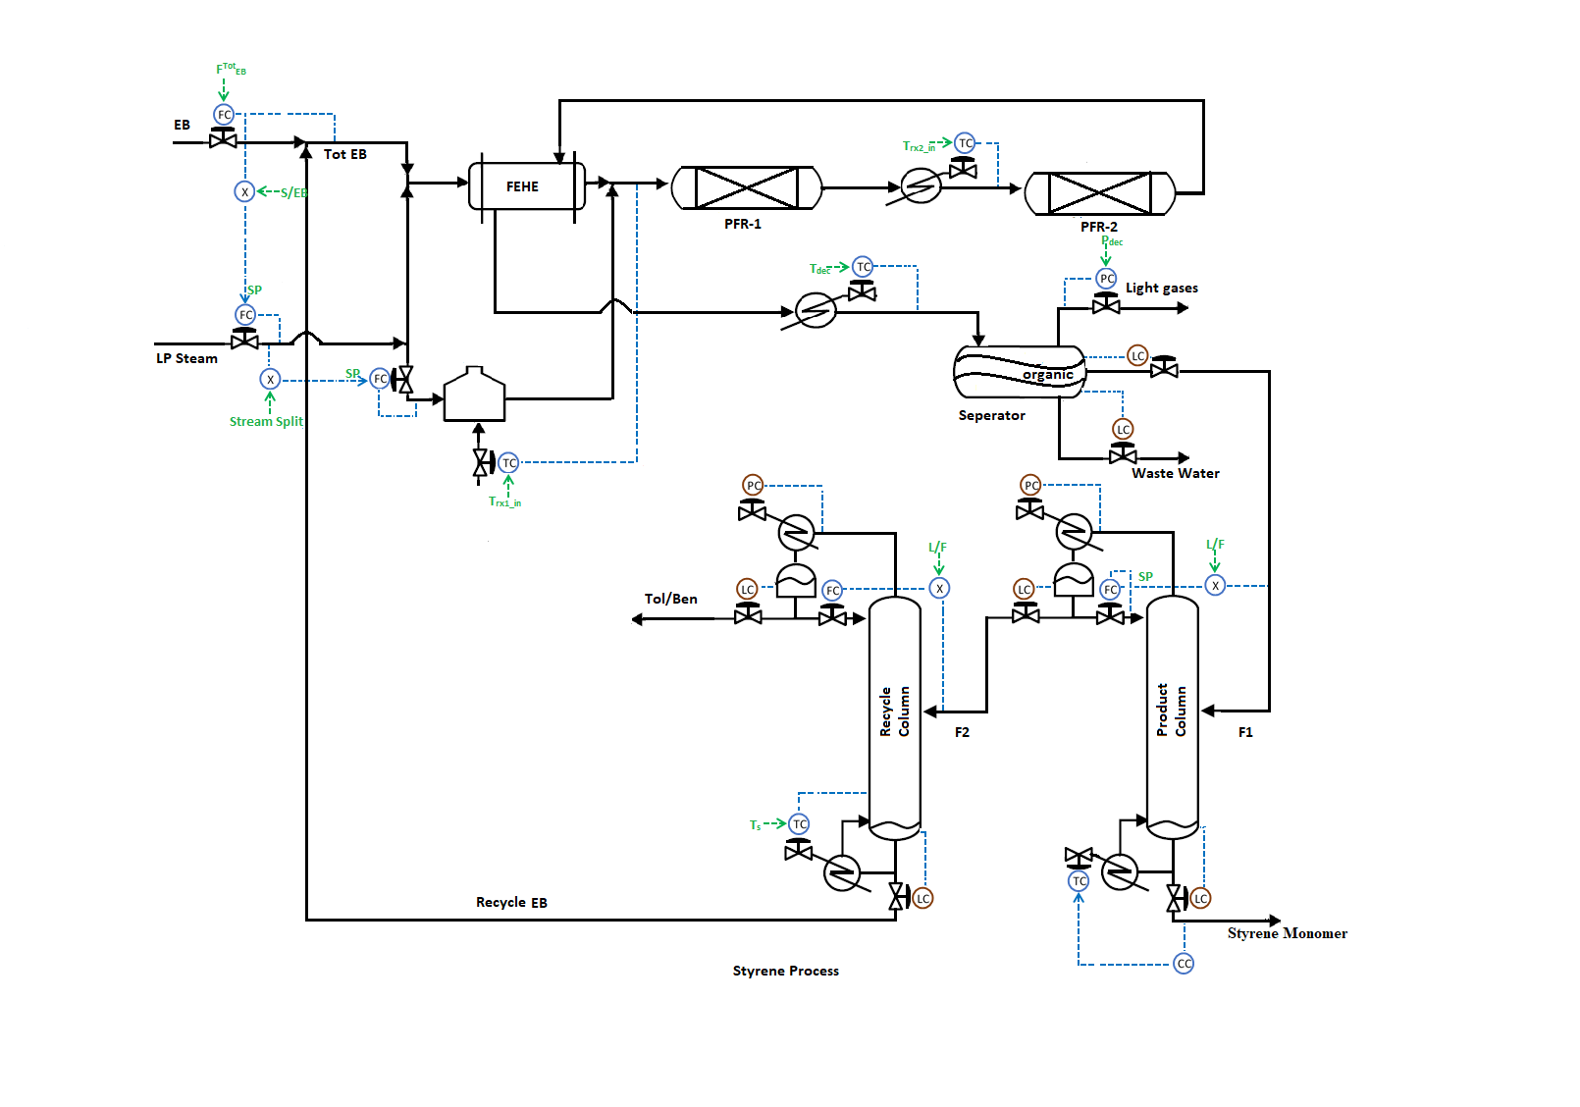**Flowsheet 4**

[FTOTEB], [S/EB], [steam split(S/S1)], [Trx1_in], [Trx2_in]

[Tdec], [Pdec], [L/F]1, [xBEB]1, [Ts]2, [L/F]2

Control Degree of freedom = 19

LC = 06

Column PC = 02

SS DOF = 11

**Flowsheet 5**

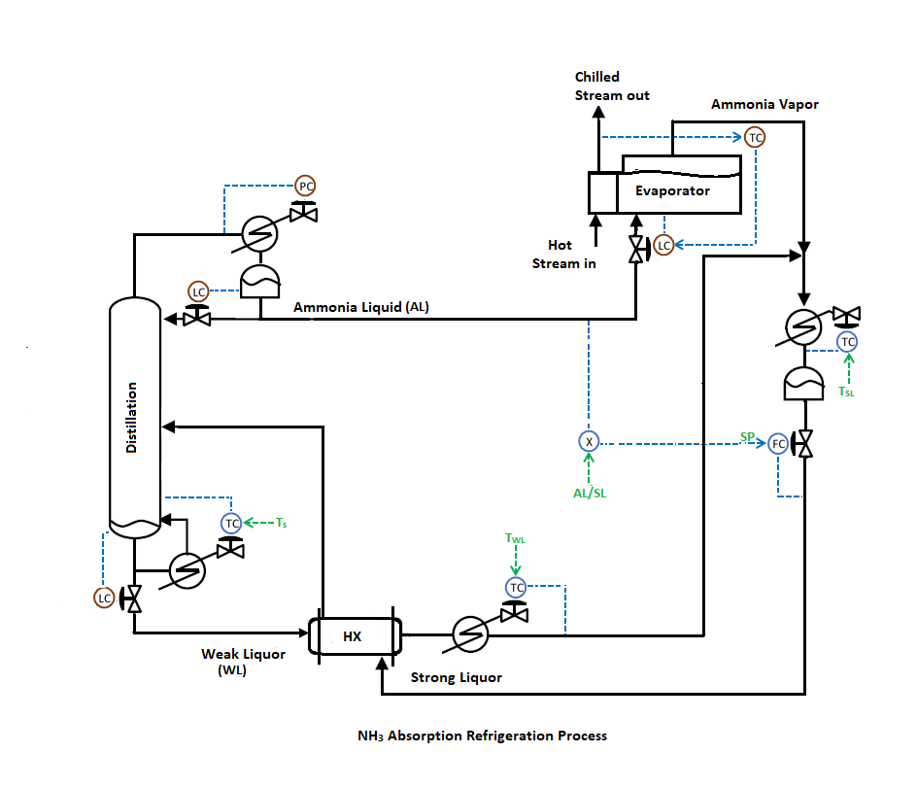

[Tstrip], [TWL], [TSL], [AL/SL]

Control Degree of freedom = 8

LC = 3

Column PC = 1

SS DOF = 4